**Externality Costs Associated with Greenhouse Emissions and Policies to Reduce Them**

Kinjal Shah

HSA10 – 5 The Economics of Oil and Energy

March 6, 2015

**1. Background**

“Earth’s climate is changing, bringing disruption and pain. 2015 was the globe’s hottest year on record, exceeding the previous record set the year before”[1] Headlines like these make the issue of climate change very real. The need to aim for a sustainable future has never been more pressing. We hear about it in our everyday lives, talk about it in discussion forums and read about it in newspapers. Yet, do we really do anything about it? The real question is, can we really do anything about it?

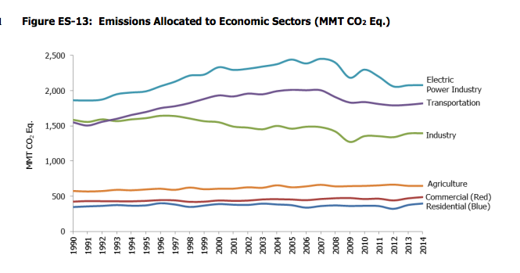As can be seen in Fig. 1, the top three contributors of CO2 emissions are the power production, transport and the industrial sectors. Residential is fairly low in the chart. Therefore, small efforts on our part to reduce our carbon footprint may have an almost negligible impact on the overall greenhouse emissions. We need to target the industrial sectors to make a significant impact on the overall greenhouse gas emissions. Here, we are looking specifically at CO2 emissions because CO2 is by far the most emitted greenhouse gas in the US. Fig. 2 illustrates this and as we can see, CO2 emissions constitute 81 % of the total greenhouse emissions in 2014 in the US, which is a huge percentage.

*Fig. 1 – CO2 emission by different sectors in US[2]*

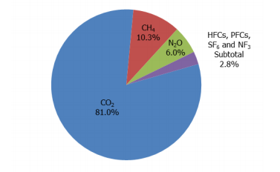 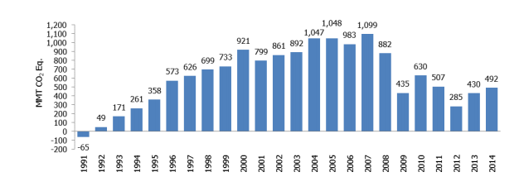

*Fig. 2 – Greenhouse gas emissions in the US by gas as of 2014[3] (Left)*

*Fig. 3 – Annual Greenhouse Emissions relative to 1990 (1990 = 0)[4] (Right)*

Fig. 3 illustrates emissions of greenhouse gases relative to 1990. As can be seen from the plot, greenhouse emissions were at their highest in mid 2000’s, with the rapid growth of the economy and development of the country. However, as the issue of climate change and global warming started becoming a serious issue, greenhouse emissions have been on the fall. Unfortunately, the last few years have again seen a rise in greenhouse emissions as the need for power, transport and goods and services has increased. Industries look to minimize their costs in order to survive in a competitive market and the ‘greener’ way is seldom the cheap one. This leads to most industries resorting to ‘unclean’ methods of production, which harms the environment.

**2. Externality Costs Due to Pollution and Market Failure**

When companies fail to take costs to the society as a whole into account, the concept of a market failure is introduced. When any decision is made, there are essentially three costs associated with it. Private costs, external costs and social costs. Private cost, as the name suggests is the cost to the firm/individual of making a decision. External cost is the cost to a third-party that is not involved in the decision-making. Lastly, social cost is the sum of private and external costs. We can now analyze our current scenario and determine the different costs associated with emitting greenhouse gases in the environment. Here, private costs include the costs to the firm of producing the good (machinery, labor, land and so on). External costs include the pollution of natural resources such as air, global warming, acid rain and social cost is the sum of private and external costs. This type of externality is called a negative externality of production because there is a overall negative effect on society due to production methods adopted by industries. The situation of negative externality of production can be summarized in Fig. 4.

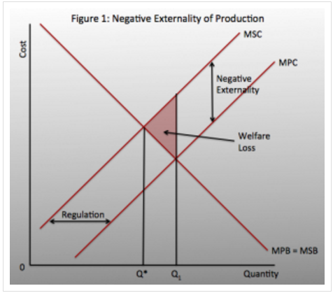

A negative externality of production makes the marginal social cost (MSC) greater than the marginal private cost (MPC), due to the presence of external costs. If we look at any given quantity and draw a vertical line up to the MPC and MSC graphs, we can see that MSC is greater than MPC. Market is producing at Q1 however, the optimum amount of emissions should be where MSC = MSB, which is at Q*.

*Fig. 4 – Negative Externality of Production[5]*

We live in a world where resources are scarce and the questions - ‘What to produce?’ ‘How do produce?’ and ‘For whom to produce? have to be answered to allocate resources. In a free market, the quantity where demand meets supply is considered the social optimum. At this point, no one can be better off without someone else being worse off – it is the most allocative efficient situation the market can be in. In this situation, social optimum is at Q*. However, we are producing greenhouse emissions at Q1. Clearly, there is an overproduction, which needs to be reduced.

We therefore see that there is an over-allocation of resources towards production methods that emit greenhouse gases. We need to correct the market failure. This requires government intervention because the free market has failed to allocate resources in the best interests of society. Governments have several policies they can implement in order to restrict the amount of emissions by these industries. These include market-based policies such as introducing a cap-and-trade program and imposing carbon taxes or command-and-control policies such as enforcing strict laws and regulations.

**3. Government Policies**

**3.1 Cap-and-Trade**

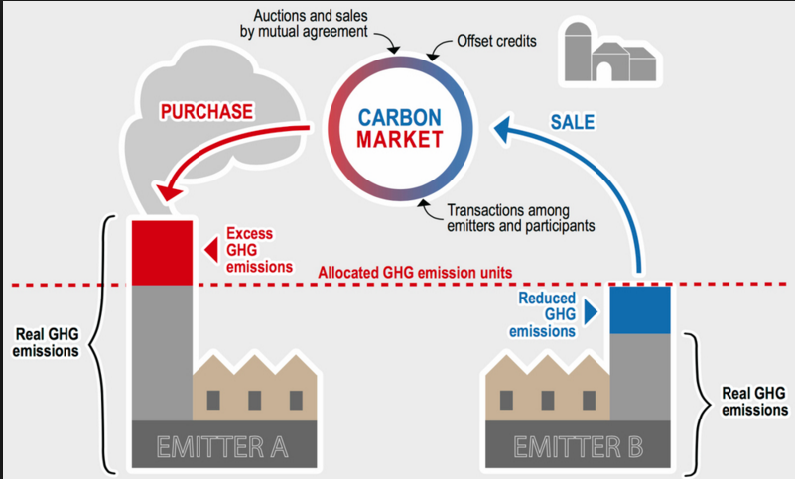The approach here is that the regulators set a maximum cap on the total amount of emissions from all firms enrolled in the program, allowing a specific environmental objective or target to be me met[6]. This cap can be lowered as time progresses to reduce the amount of greenhouse emissions in the atmosphere. Individual firms or companies enrolled in the program have to obtain a pollution permit for each

*Fig. 5 – Illustration of cap-and-trade[7]*

unit of emissions in the atmosphere. To begin with, they are given some number of permits and then if they pollute more than what the initial permit allows them to, they have to buy some from other firms who have extra permits. This stimulates a trading platform as some companies are better at switching to ‘cleaner’ methods than others and they can use this to their advantage by selling their extra permits to ‘unclean’ firms[8]. A demand and a supply for permits is therefore created. The price of the permits depends on the demand for the permits. Demand is likely to be high during an economic boom as production levels would be high and demand is likely to be low during an economic downturn when production is reduced. However, the economic performance of a country is not the sole determinant of the demand for permits.

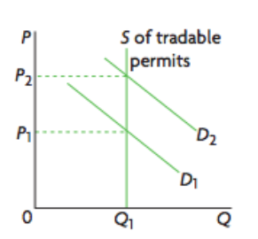

As can be seen in Fig. 6, the supply of permits is fixed and is represented by a singular vertical line. If demand increases (shifts to the left), the price of permits increases and vice versa.

*Fig. 6 – Increase in demand leads to*

*an increase in price[9]*

There are two main ways the initial permits are distributed:

1. Grandfathering

This has been the traditional way of distributing permits. In this case, the regulators release a fixed number of permits to each firm in the program for free and then allow them to trade. This is favored by businesses because they are receiving rights to pollute for free. However, this generates no revenue for the regulators, making the implementation of the program fairly expensive.

1. Auctioning

Many new cap-and-trade programs are adopting this method, at least partly, to distribute initial permits. Here, the regulators hold an auction to sell the initial number of permits and the price is determined again by demand for the permits. This approach opens a pathway to generate revenue, which can be directed towards implementation of the program.

**3.2 Carbon Tax**

Although there have increasing efforts to switch to renewable sources such as solar and wind, there is no major breakthrough in technology that will allow us to completely use clean, renewable sources. They are all seemingly long-term projects because many of them will fail to be competitive enough with our non-renewable sources in use right now such as coal and oil. One of the main reasons this is so is that these energy sources do not take into account the costs to the environment and are therefore severely underpriced. A carbon tax directly tackles this by placing a tax on the CO2 emissions, thereby increasing the price, in the hope that this acts as a price signal and encourages firms to innovate and switch to cleaner methods.

**3.3 Regulations and Laws**

Carbon tax and cap-and-trade have been market-based policies. We can also have a more command-and-control approach where the government imposes laws and regulations to limit CO2 emissions to a certain amount without allowing for any flexibility. For example, it could demand all firms/industries to use a particular technology or adhere to a certain standard.

**4. Which One is Better?**

Let us first compare command-and-control vs. market policies. Taking a command and control approach rather than a market based is likely to be faced with political opposition because industries will be seriously affected by it. This approach offers no flexibility to firms, as it forces them to adopt a method that the government wants them to. This may result in a huge increase in costs of productions as new technology has high initial costs. Moreover, industries will pass on the increase in costs to consumers to maintain their profit margin, possibly causing cost-push inflation if the commodities cover a large percentage of consumer goods. Cost-push inflation is seldom good as it results in a wage-price spiral where workers demand higher wages to be able to keep up with the increase in price of commodities and this further increases the cost of production for firms, which may cause more cost-push inflation. Lastly, the presence of stringent laws and regulations may shy away foreign direct investments (FDI) into the economy. FDIs generally generate jobs, bring in new technology and help in economic growth and inflexible laws on pollution may not attract them into the economy.

Looking at the two market-based policies, we have cap-and-trade and carbon taxes. The main difference between the two is that in the case of cap-and-trade, the cost of polluting is not fixed. It is determined by the market. This gives firms the flexibility to switch to cleaner production methods if it is more cost-effective for them to do so. Sometimes, it might be cheaper for some firms to continue using the existing production methods and buy pollution permits from other cleaner industries, and they can do that. It is important to keep in mind that the overall emission value is still decreasing because other companies for whom it is cheaper to switch have done so. Therefore, there are lesser overall costs to industries with cap-and-trade because they have two options – to become clean or to buy more permits – and they can choose the one that is best suitable to them.

Apart from being flexible, trading permits also generates revenues for greener firms, thereby encouraging firms to become cleaner. This induces innovation and may direct resources towards research and development of clean technology. Furthermore, if the auctioning method of distributing initial permits is adopted (which is what most regulators use now, at least in part), it can also generate revenues for regulators, which can be used to implement the program effectively. The cost of regulating is usually high and may lead to debts if there is no source of revenue. The same is true for carbon taxes. Carbon taxes increase the cost of production and may therefore encourage firms to innovate and switch to greener technology. However, this depends on the effect a carbon tax has on the firm. If the carbon tax is too low, there is going to be an almost negligible drop in pollution levels, and if the tax is too high, there is going to be discontentment and political opposition (governments have to keep the interests of industries in mind and cannot make the tax too high as it may cause firms to move to other countries and this will be bad for the economy of the country). A suitable standard has to be set, which may be difficult to gauge.

I would argue that while the two market-based policies - cap-and-trade and carbon taxes – can be effective in different situations, the command-and-control approach is likely to be least effective. This is because of the foundation it is based on - lack of flexibility for the industries. This is a highly inefficient way of tackling the issue and is perhaps least effective if we take the interests of all parties involved into account. With the two market-based policies, they both essentially increase the price of carbon. For a long time, carbon has been underpriced, which was leading to overconsumption and so a rise in its price is desirable. They both generate revenues for the government (if auctioning is used) and they both correct a market failure. In the case of cap-and-trade, the reduction in quantity of emissions is certain but the cost of polluting is uncertain. Conversely, in the case of a carbon tax, the cost of polluting is certain and the reduction in the quantity of emissions is uncertain[10]. Therefore, depending on the objective of the countries, one will be more suitable than the other. It does seem that cap-and-trade would be more adopted, as we need to have a guaranteed reduction in emissions given our current global situation. Moreover, the flexibility it offers firms and the trading platform makes it very appealing as a policy. It is likely to be effective at a relatively large scale where there are multiple emitters of greenhouse gases, as that will facilitate trading. At a smaller scale, perhaps carbon tax would probably be more effective[11].

Some countries may even adopt a middle-ground strategy, which combines the concept or a carbon tax and a pollution permit. For example, there could be permits but the price of carbon can only fluctuate between a price ceiling and a price floor (an upper and a lower bound). This reduced uncertainty associated with cost of polluting while maintaining the benefit of guaranteed reduction in emissions.

[Word Count – 2406 words]

1. http://www.carbontax.org/
2. EPA – Inventory of US Greenhouse Gas Emissions and Sinks – 1990 - 2014
3. EPA – Inventory of US Greenhouse Gas Emissions and Sinks – 1990 – 2014
4. EPA – Inventory of US Greenhouse Gas Emissions and Sinks – 1990 – 2014
5. http://blogs.swa-jkt.com/swa/10319/2013/11/21/1038/
6. EDF - https://www.edf.org/climate/how-cap-and-trade-works
7. Oil Sands Magazine - http://www.oilsandsmagazine.com/greenhouse-gas-emissions-carbon-pricing-alberta-cap-and-trade-explained/
8. The Guardian - http://www.theguardian.com/environment/2013/jan/31/carbon-tax-cap-and-trade
9. Cambridge University Press – Important Diagrams to Remember IB
10. The Guardian - http://www.theguardian.com/environment/2013/jan/31/carbon-tax-cap-and-trade
11. EPA – Cap and Trade Essentials - http://www3.epa.gov/captrade/documents/ctessentials.pdf